Models
Multi-Compartment Model (MCM)  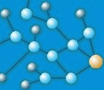  Mixing and compartment models are used for hydrograph separation, end member mixing analysis and water quality studies. MCM is an inverse multi-end-member compartment model for flow system analysis that has been developed by Eilon Adar and Christoph Kuells.  Geohydrological Model (GeM)  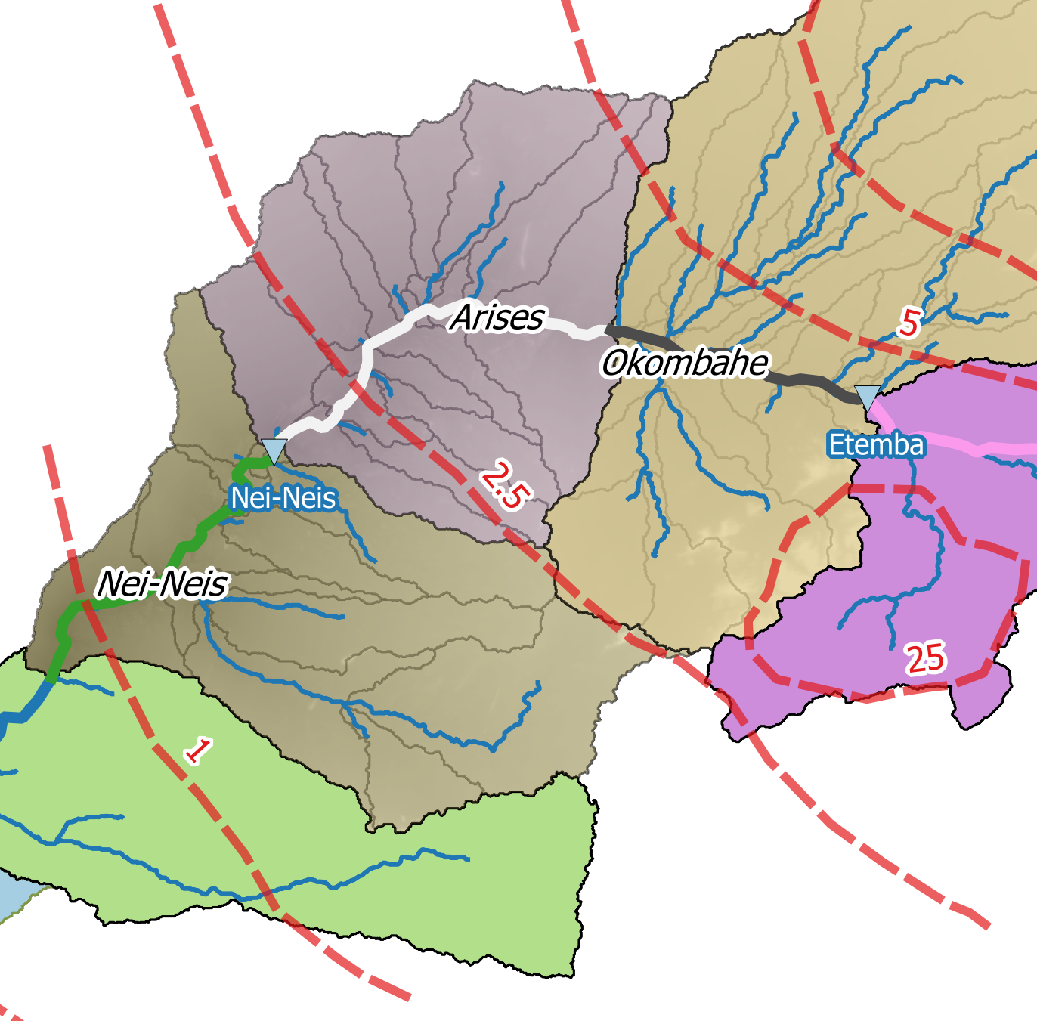  The Geohydrological Model is an interface between hydrological and groundwater models. The geohydrological model provides a basin-oriented approach to the recharge of alluvial aquifers and to their management. It fills a gap between hydrological modeling of surface hydrology, runoff production, concentration and groundwater flow and management. The alluvial aquifer is subdivided into compartments and the contributing sub-basins for each compartment are identified. The model describes and calculates indirect recharge, groundwater flow processes into, within, through and from the alluvial aquifer and handles water abstractions. Operational versions have been produced for the Kuiseb, Swakop and Omaruru rivers in Namibia. The model includes modules for abstraction of groundwater by farmers, mines and municipalities. | Access to Sustainable Water Resources  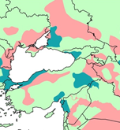  This model describes regional factors that control secure access to water resources. It is based on maps of climatological factors, hydrological topology, storage properties, socio-economic factors and engineered infrastructure. Spatial information is based on a distributed model.  Surface-Groundwater Coupling  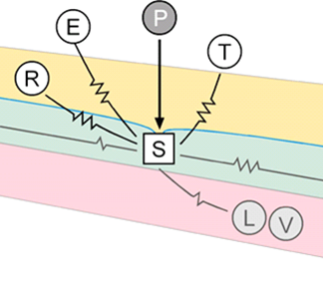  The model SuGR addresses the connection and feedbacks between surface hydrology and groundwater hydrology. It has been developped for basins with strong surface-groundwater interaction. It includes baseflow generation, indirect recharge and runoff-generation-processes during floods in different climates. It includes modules for saturation-dependent runoff production and groundwater ridging. The model is integrated with groundwater abstraction by different users, managed artificial recharge or groundwater production schemes.  Hydrological Library  Library of recipies and functions for hydrological processes and hydrological engineering methods in R and in Python.

R-Programs and Python-Code can be found on Github (under development).

