Report

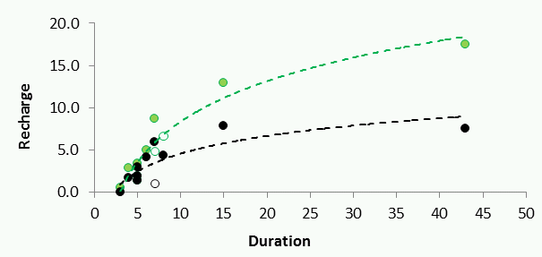

Name
Location, Year

Table of Contents

List of Figures III
List of Tables VII

1 Introduction 4
2 Stream flow characteristics 4

Bibliography
Annex

List of Figures
Figure ‎3.1: Hydrometric stations in the Kuiseb basin, from Morin et al. (2009) with their characteristics (rainfall, length, slope, width) per channel and rainfall per respective basin. 3

List of Tables
Table ‎3.1: Differences of flood volumes (Mm³). Grey fields- values are normalised to one kilometre 4

Introduction

It is now widely accepted that in arid regions, recharge occurs mainly indirectly (Hendricks & Walker 1997), i.e. via leakage from ephemeral streams. Originating in regions with higher rainfall – mountain areas of climatically different headwater basins – flash floods infiltrate into ephemeral channel beds. Stream flow characteristics
The Kuiseb River is an ephemeral stream that is dry for most of the year and sometimes even for whole years. Runoff is only generated in the upper part of the catchment. Only if the volume of runoff generated is large enough, it also reaches the Lower Kuiseb area without completely evaporating or infiltrating into the ground before. These so-called flash floods are relatively short and highly variable in size, duration and occurrence.
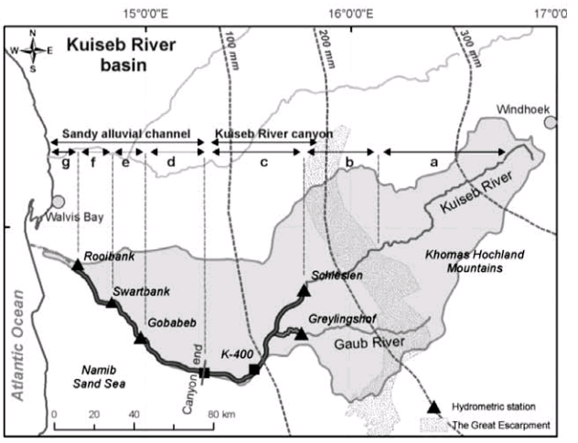

Figure ‎3.1: Hydrometric stations in the Kuiseb basin, from Morin et al. (2009) with their characteristics (rainfall, length, slope, width) per channel and rainfall per respective basin.

Based on these data a first estimate of loss rates can be obtained. As shown in Figure ‎3.1 the reaches between Gobabeb and Swartbank (e) and Swartbank and Roibank (f) have an average length of 30 and 33 km and respective widths of 68 to 74 m. The corresponding area is therefore 3*10⁴*68=2.04E+06 m² or 2.04 km². If average flow durations of 10 days for Gobabeb, 5 days for Swartbank and 4 days for Roibank are assumed, the average loss rate per section can be calculated.

Table ‎3.1: Differences of flood volumes (Mm³). Grey fields- values are normalised to one kilometre

Return period (a) | Schlesien- Gobabeb | Schlesien-Gobabeb per kilometre | Gobabeb -Swartbank | Gobabeb-Swartbank per kilometre | Swartbank -Roibank | Swartbank-Roibank per kilometre
1,5 | 1,88 | 0,02 | 2,03 | 0,06 | 0,62 | 0,02
5 | 4,47 | 0,04 | 5,32 | 0,15 | 2,59 | 0,08
10 | 5,69 | 0,06 | 6,87 | 0,20 | 3,53 | 0,11
50 | 8,37 | 0,08 | 10,28 | 0,29 | 5,57 | 0,17
100 | 9,51 | 0,10 | 11,72 | 0,33 | 6,44 | 0,20
> 100 | 13,26 | 0,13 | 16,48 | 0,47 | 9,30 | 0,29

It is already integrated and accounted for in the measured infiltration rates (Dahan et al. 2008), in routing models (Morin et al. (2009) and results obtained from volume differences (see Table ‎3.1).

References
Hendrickx, M.H. & Walker, G.R. (1997): Recharge from precipitation. In: Simmers, I. (Editor): Recharge of phreatic aquifers in (semi-) arid areas, p. 21. Balkema, Rotterdam.

Hellwig, D. H. R. (1973): Evaporation of water from sand, 3: The loss of water into the atmosphere from a sandy river bed under arid climatic conditions. Journal of Hydrology, 18(3-4), 305-316.

Külls, c., leibundgut, ch., schwartz, u. & schick, a. P. (1995): Channel infiltration study using dye tracers. IAHS Publ. no. 232, 429-436.

Annex

List of abbreviations and symbols:

1-D |  | One-dimensional
2-D |  | Two-dimensional
3-D |  | Three-dimensional
DAFLOW |  | Diffusion analogy surface-water flow model
MODFLOW |  | Modular finite-difference groundwater flow model
m a.s.l. | [m] | Meters above sea level
Q | [m³/s] | Discharge
x | [m] | Distance along channel
A | [m²] | Cross-sectional area
t | [s] | Time
u | [m/s] | Velocity
g | [m²/s] | Acceleration of gravity
y | [m] | Depth
S_{f} | [-] | Friction slope
S_{o} | [-] | Streambed slope
D_{f} | [-] | Wave diffusion coefficient
Q_{s} | [m³/s] | Flow under steady uniform conditions
C | [m/s] | Celerity of moving wave
A₀ | [m²] | Average cross-sectional area at zero flow
B | [-] | Hydraulic geometry coefficient for area
C | [-] | Hydraulic geometry exponent for area
W | [m] | Top width of channel
E | [-] | Hydraulic geometry coefficient for width
F | [-] | Hydraulic geometry exponent for width
K_{be} | [m/s] | Hydraulic conductivity of riverbed
K_{aq} | [m/s] | Hydraulic conductivity of aquifer
H or h | [m] | Head of aquifer
B_{e} | [m] | Average elevation of riverbed
B_{t} | [m] | Thickness of streambed
S_{ep} | [] | Seepage flow
V | [m³] | Volume
I | [m] | Additional change in aquifer head due to infiltration
Depth to WTable or DWT | [m] | Depth to water table
AqTh or AT | [m] | Aquifer thickness
Inf | [m³/s] | Rate of infiltration / rate of exfiltration

