Group 1
(015.028.010 surface water
014.019 groundwater type2
006.008.023.026. groundwater 016.005.011
017 spring)
This group mainly consists of 2 types of groundwater and few other types like 1 surface water and 1spring. They all have high Ca²⁺ concentration, and lower Mg²⁺ and Na⁺+K⁺ concentration. For anions, CO₃²⁻+HCO₃⁻ is higher, CI⁻+NO₃⁻ and SO₄²⁻ are lower.
Most of the ions in the water sample is under saturation, except the calcite of WK028, the aragonite and calcite of the WK019 and WK026.
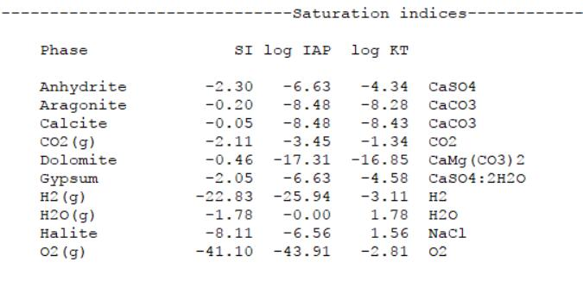
The typical one WK010 is shown.

Group 2
(024 sea water
025 salty groundwater)
Na⁺+K⁺ pretty high, Mg²⁺ low, Ca²⁺ super low
CI⁻+NO₃⁻ are considerably high, SO₄²⁻ is low, and CO32-+ HCO3- are nearly zero.
All the ions in the sample is under saturation.
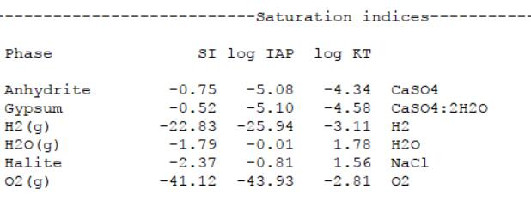
The typical one WK025 is shown.
Group 3
(018 spring and 022 salt lake)
There two both have nearly equal concentration of Na⁺+K⁺ and Ca²⁺, Mg²⁺ is much lower compared to them.
CI⁻+NO₃⁻ and CO₃²⁻+HCO₃⁻ are also nearly equal, and SO₄²⁻ are lower.
But Mg²⁺ and CI⁻+NO₃⁻ are slightly higher in salt lake than spring.
We predict these are probably mixture of group 1 and group2.
However, the aragonite and calcite of WK022 will precipitate and the picture is shown.
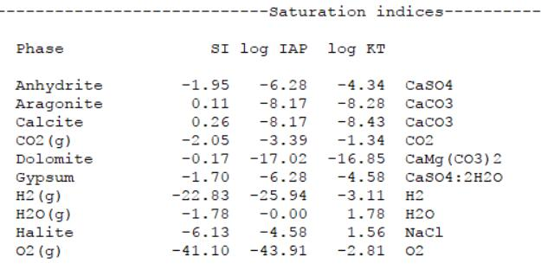

Group 4
(001.003.004.029 heraion)
Heraion plot in those areas with low Ca²⁺ low Mg²⁺, high Na⁺+K⁺, high CI⁻+NO₃⁻ low CO₃²⁻+HCO₃⁻ and low SO₄²⁻.
They might be some mixture of group1 and group2 or group3 and group3, even all of 3 groups.
The aragonite, calcite and dolomite of WK001 WK003 WK004 will precipitate. And only the calcite of WK029 will precipitate.
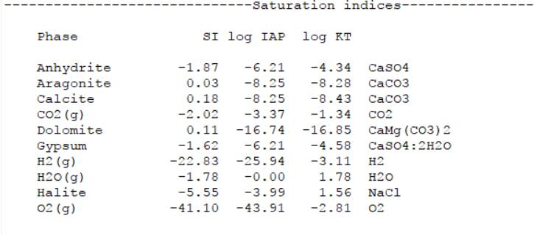
The typical one WK001 is shown.

