Determination of the fractionation of different isotopes under the influence of different gases

Chen Yunqi 305093
E-mails:
Yunqi.chen@stud.th-luebeck.de

- Introduction
Tracers in large reservoirs like the ocean, the mantle, meteoric waters and organic matter have distinct stable isotope signatures that can be used to trace the origin of rocks, fluids, plants, contaminants, and food sources. ^{[1]} The widely application of isotopes in solving fundamental problems in the earth science has raised our concern. We determined the influence factors of the kinetic and equilibrium isotope effects. The results of the experiment show the impact of different parameters on the fractionation factor. And the water samples are all from Luebeck (Schleswig-Holstein, Germany) was sampled. And we use the TDLAS (Tunable Diode Laser Absorption Spectroscopy) to determine the deference between the sample and the standard mean ocean water.

- Theoretical principles
  - Definition of isotopic abundance ratio R:

A substance containing the less abundant isotope species N_{i} and the more abundant isotope N has an isotopic abundance ratio R that is defined by ^{[2]}:

$R=\frac{N_{i}}{N}$ (1)

The standard mean ocean water (short SMOW) that has been defined by the International Atomic Energy Agency (IAEA) in Vienna as a common standard for expressing isotopic ratios (the so-called Vienna SMOW or V-SMOW) has isotopic abundance ratios of (Baertschi,1976; Hageman et al.,1970):

${R_{{}_{ }^{18}{O,standard}}=R}_{{{}_{ }^{18}O}/{{}_{ }^{16}O}}={(\frac{{}_{ }^{18}O}{{}_{ }^{16}O})}_{VSMOW}=2005.2±0.45*{10}^{-6}$ (2)

$R_{D/H}={(\frac{{}_{ }^{2}H}{{}_{ }^{1}H})}_{VSMOW}=155.76±0.05*{10}^{-6}$ (3)

In order to show the difference between the sample and the standard mean ocean water, we define $δ$ as:

$δ=\frac{R_{sample}-R_{standard}}{R_{standard}}$ (4)
The Tunable Diode Laser Absorption Spectroscopy can test the difference between the sample and the standard mean ocean water. In $δ$ notation, positive values indicate an enrichment of ${}_{ }^{18}O$ or ${}_{ }^{2}H$ compared to the standard being used whereas negative values signify a depletion of heavier isotopes in the sample. ^{[2]}

  - Definition of fractionation factor
Two different types of processes -- equilibrium and kinetic isotope effects -- cause isotope fractionation. As a consequence of fractionation processes, waters and solutes often develop unique isotopic compositions (ratios of heavy to light isotopes) that may be indicative of their source or of the processes that formed them.

Stable isotopes partitioning between two substances A and B can be expressed by the use of the isotopic fractionation factor $α$:^{[3]}

$α_{A-B}={R_{A}}/{R_{B}}$ (5)

  - Brief introduction of analysis device
The analysis device used in this experiment is TDLAS (Tunable Diode Laser Absorption Spectroscopy). The producer is Los Gatos Research. The WVIA uses LGR’s patented O-axis ICOS technology, a fourth-generation cavity enhanced absorption technique. The system composed of the WVIA and WVISS provides automated, dual-inlet operation and accurate, traceable $δ{}_{ }^{2}H, δ{}_{ }^{17}{O, }δ{}_{\begin{aligned} \\ \end{aligned}}^{18}O$ and water vapor mole fraction measurements without drift. The total measurement uncertainty of the device is under 0.1% (with WVISS). ^{[4]} A basic TDLAS setup consists of tunable diode laser light source, transmitting optics, optically accessible absorbing medium, receiving optics and detectors. ^{[5]} To determine the concentration, the wavelength of a diode laser is tuned over a particular absorption line of interest and the intensity of the transmitted radiation is measured. The transmitted intensity can be related to the concentration of the species present by the Beer-Lambert law.

- Experimental procedure
Firstly, the aluminum bags with two drops of silicon on one side are prepared. Then silicon bags are left in open air for 24 hours to solidify. Then mixed gases are added into the bag. The composition of the gases are around 79 percent nitrogen and 21 percent oxygen. After that, using the pipette to deliver 15 milliliter tap water into the bags. Then use the heat healing machine to seal the aluminum bags. Repeat the procedure to prepare three same bags and decrease the error. Secondly, prepare three aluminum bags with carbon dioxide. Thirdly, prepare three aluminum bags with a mixture of two kinds of gases. Control the adding gas of one kind to be half volume of the aluminum bags. Control the temperature to be the same. It is around 20 centigrade. Leave the sample bags for 24 hours for the gas and liquid phase to reach the equilibrium. Then start to measure the influence of different gas samples with the tunable diode laser.

4. Results
4.1 Raw data
The raw data recorded is shown in Table 1.
Table 1 Raw data recorded during the experiment
Composition of gases | Test object | Sample 1 | Sample 2 | Sample 3
N₂+O₂ | $H_{2}{}_{ }^{16}O$(ppm) | 33430 | 33150 | 33200
 | $$δ{}_{ }^{18}O(‰)$$ | -7.3 | -7.27 | -7.76
 | $$δD(‰)$$ | -38.3 | -39.18 | -41.14
 | $$δ{}_{ }^{17}O(‰)$$ | -9.25 | -9.33 | -9.72
CO₂ | $H_{2}{}_{ }^{16}O$(ppm) | 32801 | 32655 | 32290
 | $$δ{}_{ }^{18}O()(‰)$$ | -5.20 | -5.80 | -5.40
 | $$δD(‰)$$ | -51.45 | -51.70 | -51.70
 | $$δ{}_{ }^{17}O(‰)$$ | 8.05 | 6.72 | 7.30
N₂+O₂+CO₂ | $H_{2}{}_{ }^{16}O$(ppm) | 32535.0 | 33110.0 | 32875.0
 | $$δ{}_{ }^{18}O(‰)$$ | -6.55 | -6.28 | -6.70
 | $$δD(‰)$$ | -42.39 | -43.20 | -42.00
 | $$δ{}_{ }^{17}O(‰)$$ | 16.70 | 0.80 | 16.92

4.2 Calculations and Results

4.2.1 Calculation of $\overline{α{}_{ }^{18}O}$
Calculate the isotopic abundance ratio of $R_{{}_{ }^{18}{O,sample}}$:
$$R_{{}_{ }^{18}{O,sample}}=δ_{{}_{ }^{18}{O,sample}}×R_{{}_{ }^{18}{O,standard}}×0.001+R_{{}_{ }^{18}{O,standard}}$$
Calculate the fractionation factor $α_{{}_{ }^{18}{O,sample}}$:
$$α_{{}_{ }^{18}{O,sample}}=\frac{R_{{}_{ }^{18}{O,standard}}}{δ_{{}_{ }^{18}{O,sample}}×R_{{}_{ }^{18}{O,standard}}×0.001+R_{{}_{ }^{18}{O,standard}}}$$
Calculate the mean value $\overline{α_{{}_{ }^{18}{O,sample}}}$
$$\overline{α_{{}_{ }^{18}{O,sample}}}=\frac{α_{{}_{ }^{18}{O,sample1}}+α_{{}_{ }^{18}{O,sample}2}+α_{{}_{ }^{18}{O,sample}3}}{3}$$
with
$$R_{{}_{ }^{18}{O,sample}}$$ | is the isotopic abundance ratio of ${}_{ }^{18}O$
$$δ_{{}_{ }^{18}{O,sample}}$$ | is difference between isotopic ratios in $δ$ notation
$$R_{{}_{ }^{18}{O,standard}}$$  $$α_{{}_{ }^{18}{O,sample}}$$  $$\overline{α_{{}_{ }^{18}{O,sample}}}$$ | is the standard isotopic ratio of ${}_{ }^{18}O$  is the fractionation factor of ${}_{ }^{18}O$ of the sample  is the mean value of $α_{{}_{ }^{18}{O,sample}}$

The calculation results of the degree of fractionation $α_{{}_{ }^{18}{O,sample}}$ and the mean value $\overline{α_{{}_{ }^{18}{O,sample}}}$are shown as table 2.

Table 2 Calculated results for $R_{{}_{ }^{18}{O,sample}}$
 |  | $$α_{{}_{ }^{18}{O,sample}}$$ | $$\overline{α_{{}_{ }^{18}{O,sample}}}$$
N₂+O₂ | Sample 1 | 1.0074 | 1.0075
 | Sample 2 | 1.0073
 | Sample 3 | 1.0078
CO₂ | Sample 1 | 1.0052 | 1.0055
 | Sample 2 | 1.0058
 | Sample 3 | 1.0054
N₂+O₂+CO₂ | Sample 1 | 1.0066 | 1.0066
 | Sample 2 | 1.0063
 | Sample 3 | 1.0067

4.2.2 Calculation of $\overline{α_{D}}$
Calculate the isotopic abundance ratio of $R_{D,sample}$:
$$R_{D,sample}=δ_{D,sample}×R_{D,standard}×0.001+R_{D,standard}$$
Calculate the degree of fractionation $α_{D,sample}$:
$$α_{D,sample}=\frac{R_{D,standard}}{δ_{D,sample}×R_{D,standard}×0.001+R_{D,standard}}$$
Calculate the mean value $\overline{α_{D,sample}}$
$$\overline{α_{D,sample}}=\frac{α_{D,sample1}+α_{D,sample2}+α_{D,sample3}}{3}$$
with
$$R_{D,sample}$$ | is the isotopic abundance ratio of $D$
$$δ_{D,sample}$$ | is difference between isotopic ratios in $δ$ notation
$$R_{D,standard}$$  $$α_{D,sample}$$  $$\overline{α_{D,sample}}$$ | is the standard isotopic ratio of $D$  is the fractionation factor of $D$ in the sample  is the mean value of $α_{D,sample}$

The calculation results of the fractionation factor $α_{D,sample}$ and the mean value $\overline{α_{D,sample}}$are shown as table 2.

Table 3 Calculated results for $R_{{}_{ }^{18}{O,sample}}$

 |  | $$α_{D,sample}$$ | $$\overline{α_{D,sample}}$$
N₂+O₂ | Sample 1 | 1.0398 | 1.0412
 | Sample 2 | 1.0408
 | Sample 3 | 1.0429
CO₂ | Sample 1 | 1.0542 | 1.0544
 | Sample 2 | 1.0545
 | Sample 3 | 1.0545
N₂+O₂+CO₂ | Sample 1 | 1.0443 | 1.0444
 | Sample 2 | 1.0452
 | Sample 3 | 1.0438

4.2.3 The change of fractionation factor under different gas composition

Table 4 Final result of the fractionation factor
 | N₂+O₂ | N₂+O₂+ CO₂ | CO₂
$$\overline{α_{{}_{ }^{18}{O,sample}}}$$ | 1.0075 | 1.0066 | 1.0055
$$\overline{α_{D,sample}}$$ | 1.0412 | 1.0444 | 1.0544

Graph 1 Tendency of isotopic abundance ratios under different gas circumstance
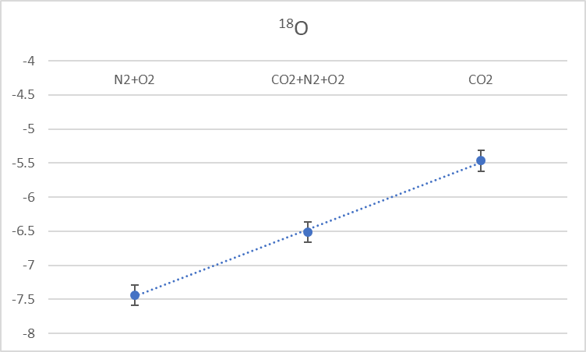

Graph 2 Tendency of isotopic abundance ratios under different gas circumstance
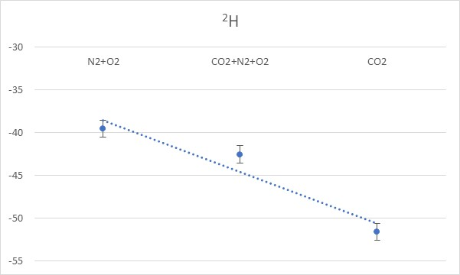
Graph 3 The change of fractionation factor under different gas composition
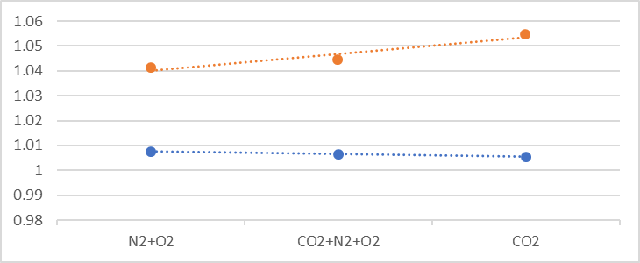

- Discussion
  - Discussion of the experiment error
Table 5 The standard deviation $σ$ of the raw data
 | $σ_{{}_{ }^{18}O}$(%) | $σ_{D}$ (%)
N₂+O₂ | 0.0275 | 0.1454
CO₂ | 0.0306 | 0.0144
N₂+O₂+CO₂ | 0.02128 | 0.06121
The standard deviation shown in the table 5 means the difference between each sample is relatively small. And there is no outliner within these nine samples. In order to further control the error, we can wait longer to ensure two phases to reach an equilibrium. Also, it takes time for the sample gas to circulate inside the analysis device and the result is always fluctuating. Thus, the numbers we recorded may have error. What’s more, although the gas pressure has little impact on the final result, the volume ratio of gas phase and liquid phase may influence the final result. Because the total volume of gas we added into the aluminum bag was hard to control.
  - Analysis of the final result
According to Graph 3, the fractionation factor $α_{D}$ was increasing with the augmentation of CO₂. On the contrary, the fractionation factor $α_{{}_{ }^{18}O}$ was decreasing with the augmentation of CO₂. And the increase of fractionation factor $α_{D}$ indicates the decrease of $δ_{D}$, the decrease of fractionation factor $α_{{}_{ }^{18}O}$ indicates the increase of $δ_{{}_{ }^{18}O}$. Because $δ_{D}$ and $δ_{{}_{ }^{18}O}$ are negative, the decrease of $δ$means the increasing difference between the sample and standard situation. Thus, with the augmentation of CO₂, the concentration of D in the gas phase is decreasing and the concentration of ${}_{ }^{18}O$ in the gas phase is increasing. As a result, D may be inhibited with the increasement of CO₂ and ${}_{ }^{18}O$ may be enhanced with the increasement of CO₂.

- References
[1] Zachary Sharp (2017). Principles of Stable Isotope Geochemistry, 2nd Edition.
[2] Christian Leibundgut, Piotr Maloszewski, and Christoph Kuells(2009). Tracers in Hydrology.
[3] Carol Kendall (2004). Fundamentals of Stable Isotope Geochemistry.
[4] http://www.lgrinc.com/documents/LGR_WVIA_Datasheet_2016-06-30.pdf
[5] P. Zorabedian, Tunable external cavity semiconductor lasers, in Tunable Lasers Handbook, F. J. Duarte (Ed.) (Academic, New York, 1995) Chapter 8.

