Blaney-Criddle Formula
The formula was developed to estimate consumptive use of irrigated crops in the United States. It is based on similar assumptions as the evaporation model of Thorntwaite. The Blaney-Criddle formula uses temperature and day-length as independent variables. The formula reads:
with
= potential evapotranspiration in
= average air temperature in °Celsius. When is less than 3 °C, the first term in parenthesis is set to 1.38.
= an empirical factor depending on crop type and stage of growth (needs tables).
= the monthly fraction of annual hours of daylight (table).
This formula does not contain moisture and transport terms. These are included in the crop factor that should be checked for any regional application outside of U.S. and original region.
The code for this forumula is:
from pylab import *
def f(t):
d = 0.85
k= 1.9
et = (0.142*t+1.095)*(t+17.8)*k*d
return et
t = arange(0.0, 35.0, 0.5)
plot(t, f(t))
ytext = ylabel('Evaporation')
xtext = xlabel('temperature')
setp(xtext, size='medium', name='courier', weight='bold', color='g')
setp(ytext, size='medium', name='helvetica', weight='light', color='b')
show()
Evaporation depends on temperature (a proxy for available energy). Just download the python-code, run it with a python compiler.
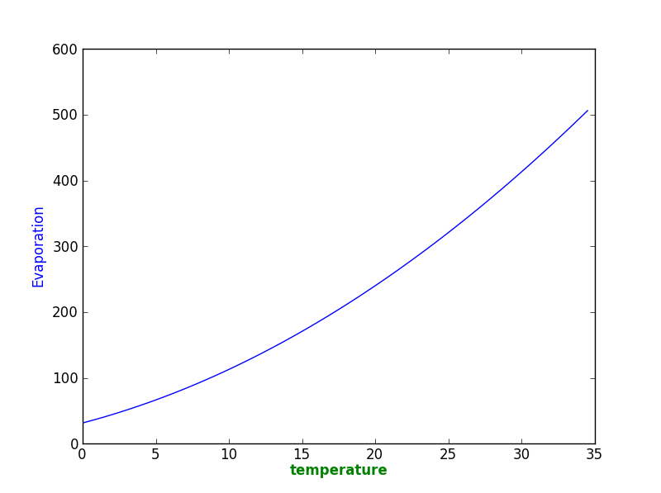
There is a formula for the whole growing season:
where
= crop coefficient for the whole season = number of months in growing season = individual month in the growing season so that and are the air temperature in ° Celsius and the fraction of annual hours of daylight for each month.

