List of Lectures
The study program Water Engineering informs about courses, professors, news and events related to this course for international students. For our lectures e-learning systems have been set up at e-learning for environmental hydrologists. Watch out at the bottom of each teaser text for each lecture.

Master Environmental Engineering
Hydrological Engineering  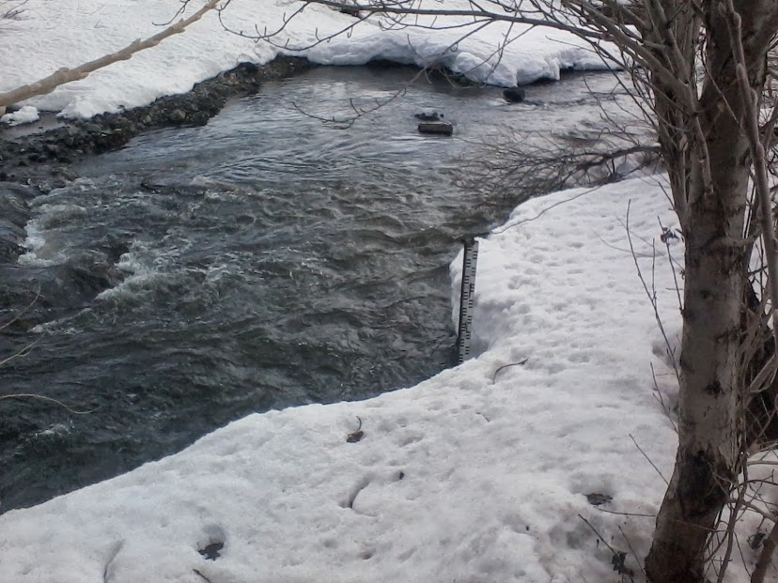  The course introduces principles and methods of sustainable water resources management for the Master Water Engineering. The course includes water resources assessment and the necessary hydrological background on processes and water balances, integrated water resources assessment, flood and drought risk assessment, management and mitigation and planning for environmental hydrology.  Notes on Sustainable Water Management | Simulation and Modeling  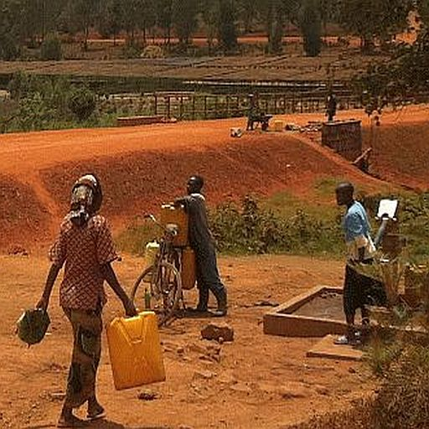  The master course includes modeling of water quality, transport modeling in rivers and lakes, groundwater flow and transport modeling, solute transport in aquifers for the restoration of aquatic systems and water engineering with corresponding techniques. The course introduces the use of Python for hydrological modeling.  Hydrological Modeling Notes  PhreeqC

Advanced Study Courses
Tracer Hydrology  The course on tracer hydrology introduces the principles of the use of tracers in hydrology. Environmental tracers and artificial tracers are presented, methods of applying them for hydrological studies, interpretation and modeling. The lecture is offered as a block course at TU Darmstadt.  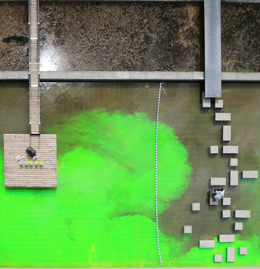 Tracer | Environmental Tracers  The course introduces and demonstrates environmental isotope field techniques with sampling, monitoring, analysis and interpretation. Analysis of recharge and solute transport are presented. Course announcements are given on our news page. Participants can access notes of the lecture, slides, links and videos here.  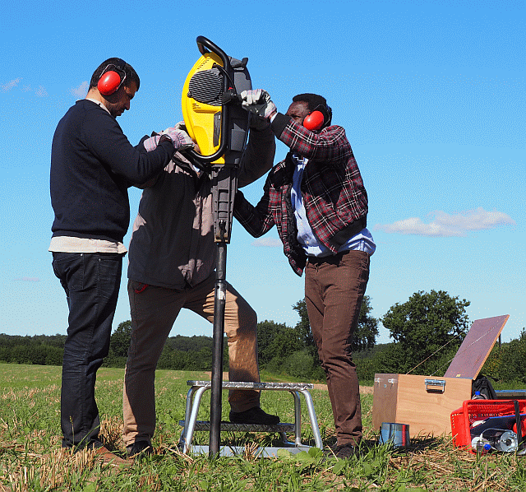 Summer School

