←:en:research:start|previous page ^:en:start|Start^ :en:models:start|next page →

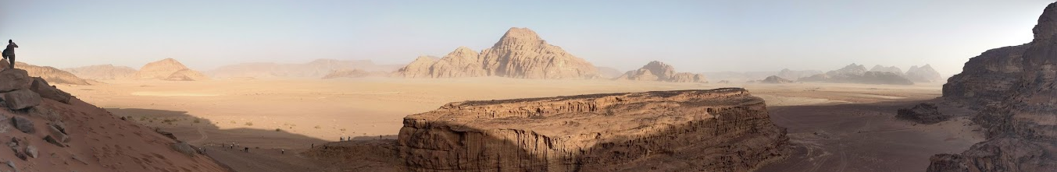 Wadi

Projects
Current Projects  Water Supply of Ancient Cities  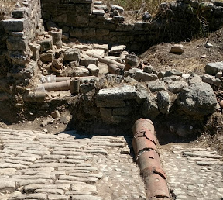  Water and cult of the Heraion: German Research Foundation (DFG) 2016-2019, project in cooperation with DAI (German Archeological Institute) on the paleo- und modern hydrology and hydrogeology of the ancient temple of Hera site. The site is affected by recurrent inundation and flooding. The hydrological processes and water balance of the site is established in order to better understand the ancient water supply system, its vulnerability to droughts and floods and in order to establish the causes and mitigate the impact of flooding at the modern site. A bibliography of studies on this archeological site with special reference to the hydrological can be found at our bibsonomy group  ISOMED  The project ISOMED aims at developing innovative methods for estimating environmental flows with the ultimate objective of increasing water use efficiency and reaching sustainability. Sustainability is defined as resilient balance of water resources renewal and uses within hydrological systems under anthropogenic pressure at various scales.  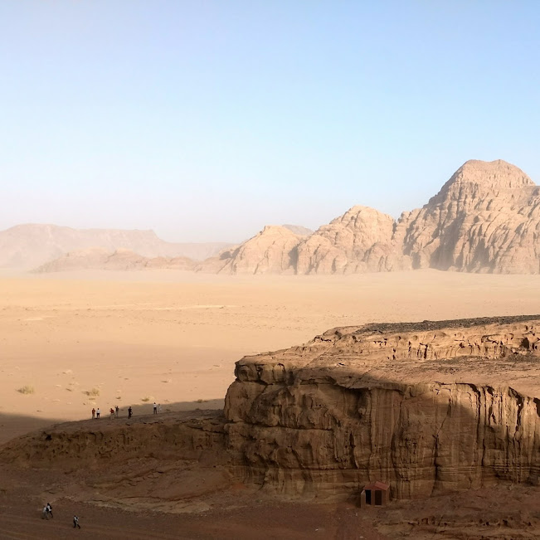 ISOMED  Project coordination with Collabtive | Completed Projects  - Integrated Water Management of the Omaruru Basin: Project with SLR to develop an integrated water management model of the Omaruru Basin in Namibia  - Water Quality Accounts for the Swakop Basin: Project with SLR to develop a water quality accounting system - case study in the Swakop Basin / Namibia.  - Water Accounts: Methodology for Developping Water Accounts - Pilot and Capacity Building.  - SEA: Strategic Planning of Water Resources of the Erongo Region. BIWAC, GSN, DWA, BGR. October 2010 until March 2011.  - WADE  - ITER  - Guarani-Aquifer Project  - Groundwater Resources Re-Evaluation of Cyprus  - WAVES  - GREM - Groundwater Resources in the Eastern Mediterranean
  - groundwater model of Heraion site
  - coupling to hydrological model
  - scenario analysis of ancient droughts and floods
  - concept to reduce flooding
  - sites in Cyprus and Jordan
  - novel recharge estimation methods
  - participative soil water monitoring
  - water flow accounting

